**Quote by APJ kalam**

------------------------

**I'm the best**

**I can do it. (Action, perseverance and facing your fear)**

**God is always with me**

**I'm a winner**

**Today is my day**

**I will have great aim/dream**

**I will continuously acquire knowledge**

**I will do hard work**

**I will pesifear /Perseverance and succeed.**

The code to add in Step 3: Configure instance Details under User data in EC2 instance machine is as below:

#!/bin/bash

Sudo su

Yum update -y

Echo “* * * * * root chef-client”>> /etc/crontab

---------------------------------------------

Lecture:31 What is Chef?

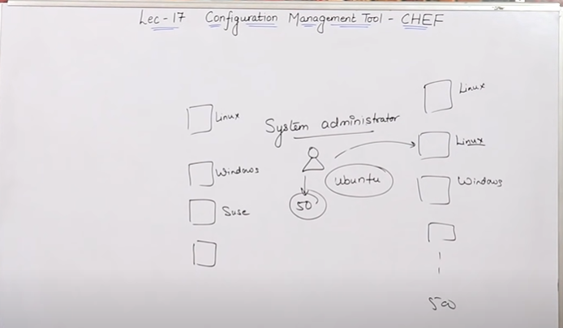

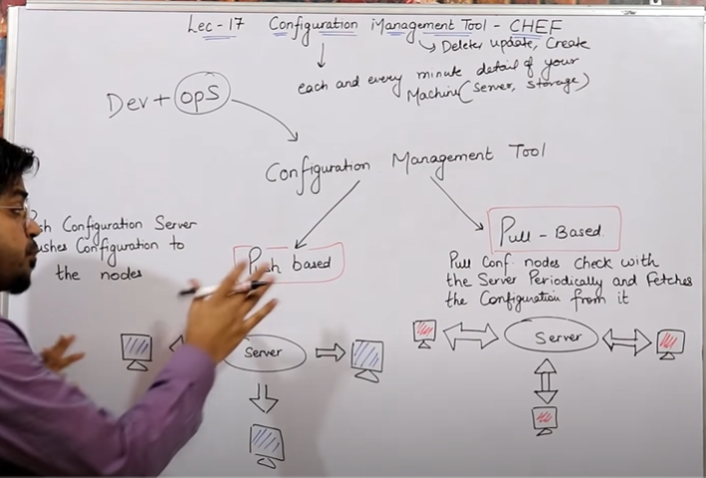

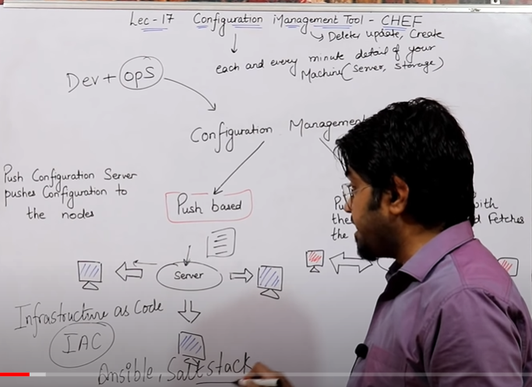

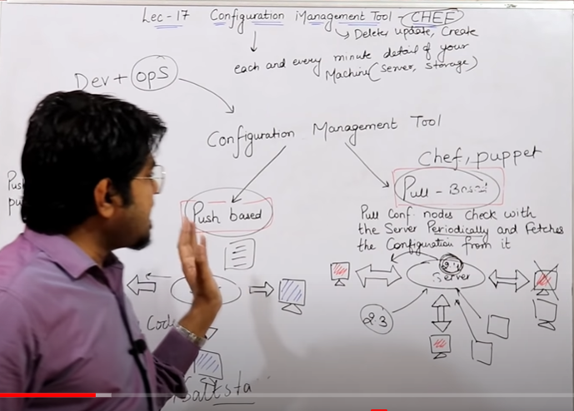

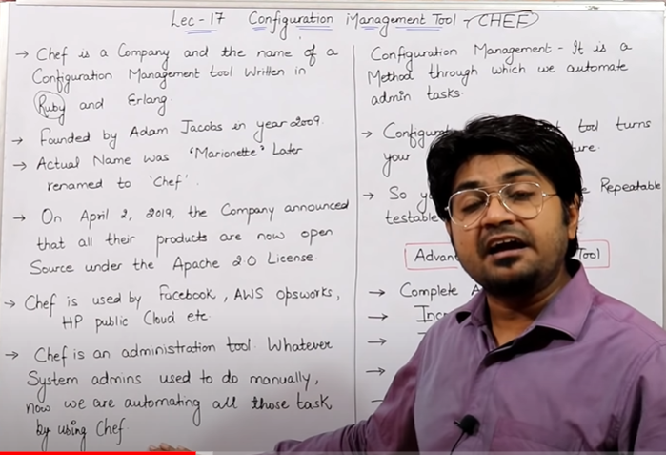

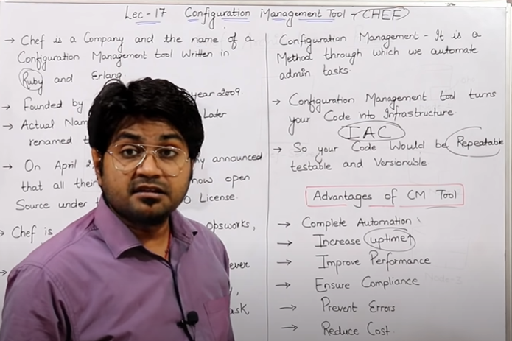

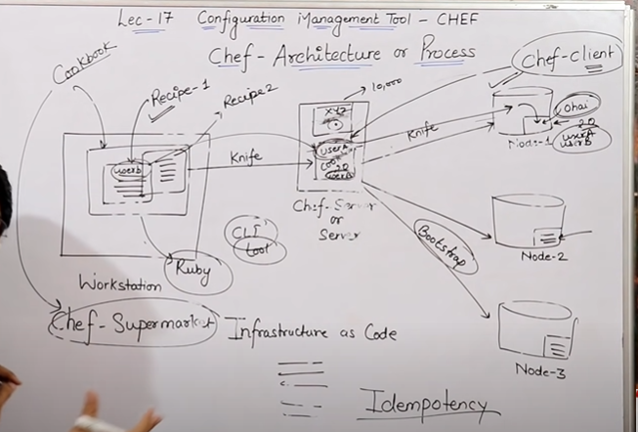

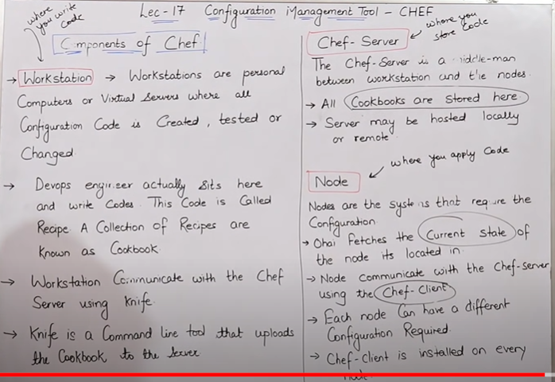

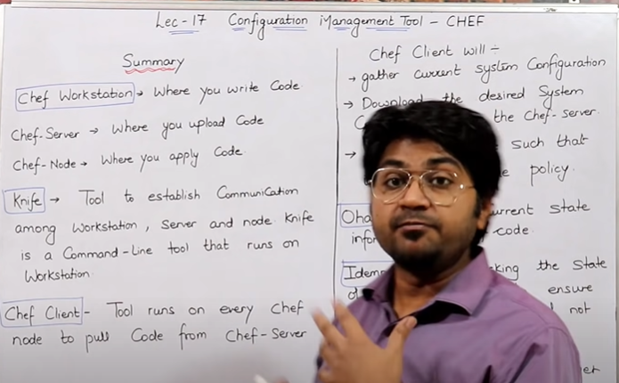

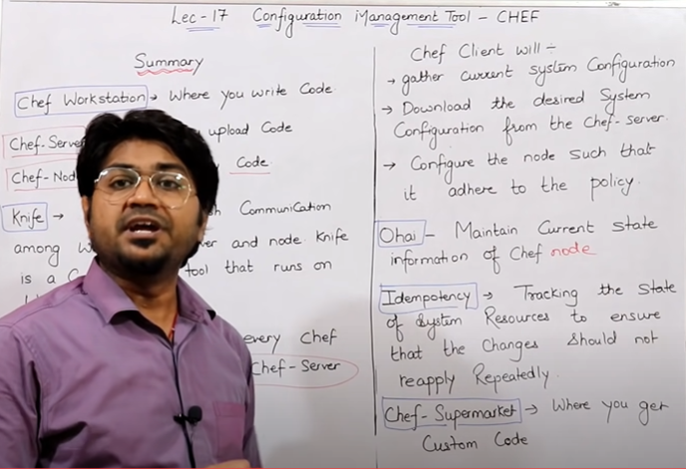

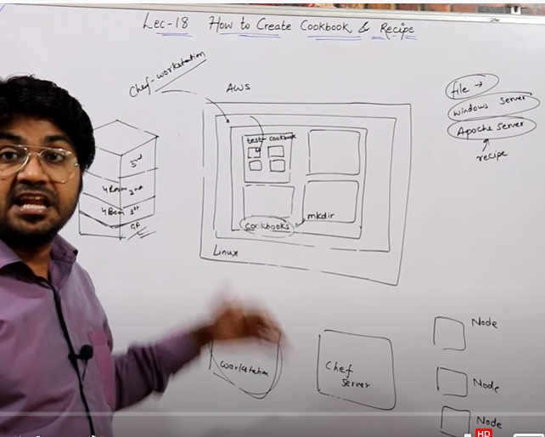

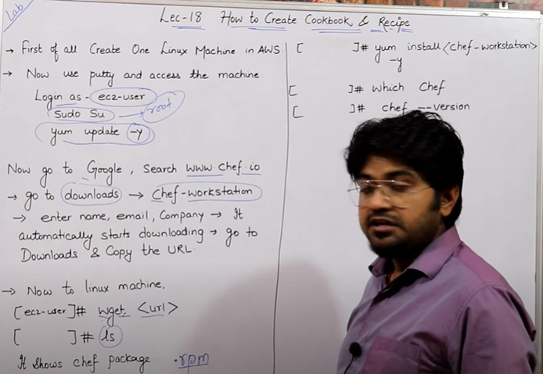

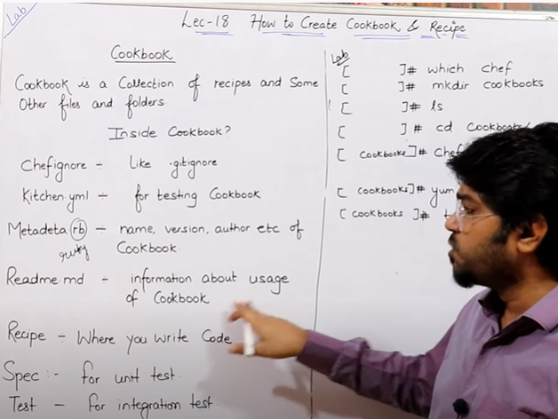

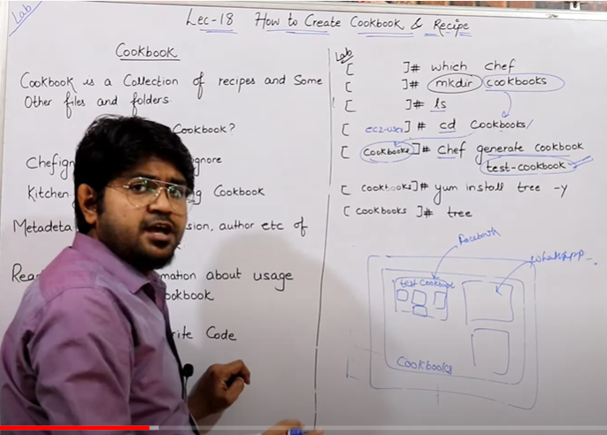

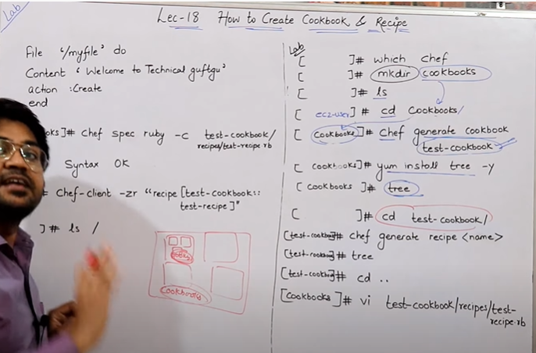

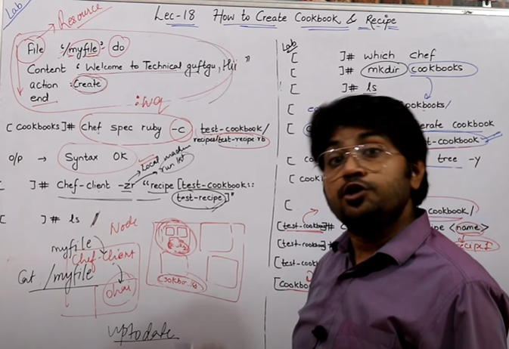

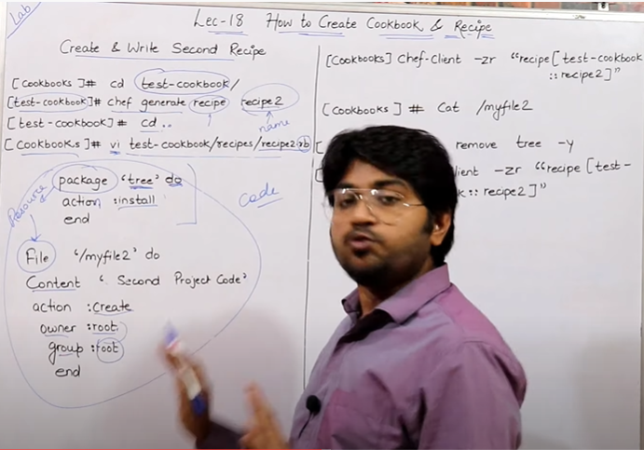

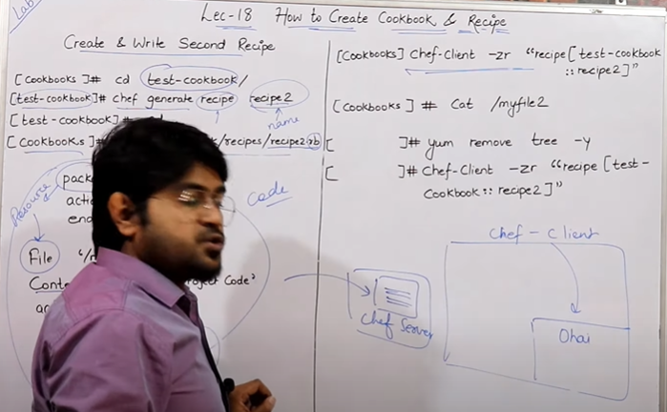

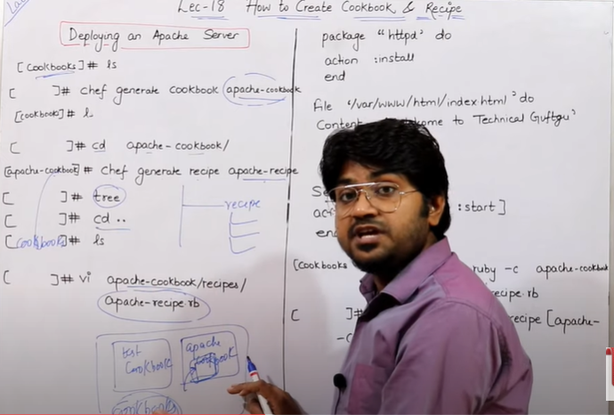

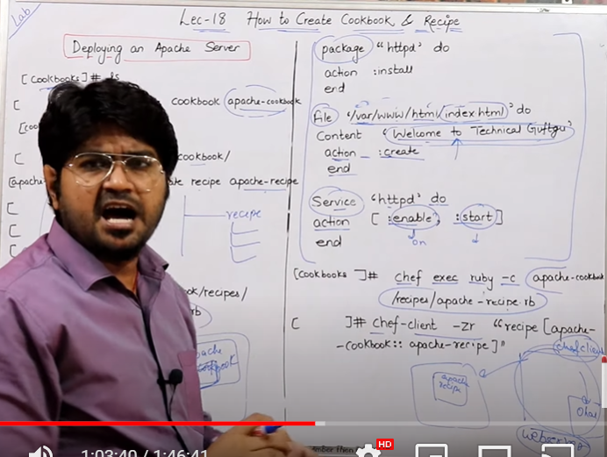

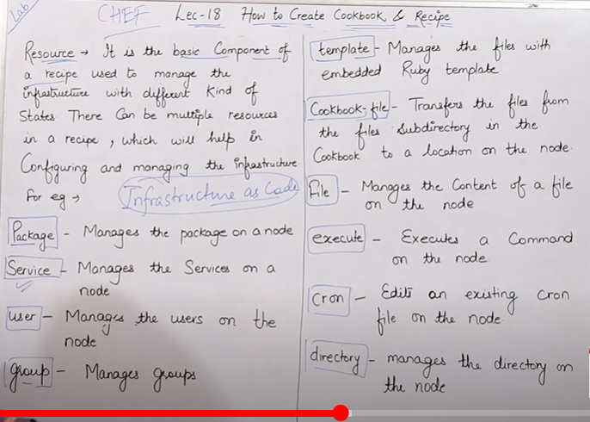

*********CODE USED IN THE LAB*******

LINK TO DOWNLOAD CHEF-WORKSTATION

<https://packages.chef.io/files/stable/chef-workstation/20.7.96/el/7/chef-workstation-20.7.96-1.el7.x86_64.rpm>

file '/myfile' do

content 'Welcome to Technical Guftgu'

action :create

end

*********

package 'tree' do

action :install

end

file '/myfile2' do

content 'This is My Second Project code'

action :create

owner 'root'

group 'root'

end

*********

package 'httpd' do

action :install

end

file '/var/www/html/index.html' do

content 'Welcome to Technical Guftgu'

action :create

end

service 'httpd' do

action [:enable, :start]

end

After this you can copy the public ip of the ec2 machine and past in the browser. It will display the code that you wrote above in the webpage.

***************************************************** **************************

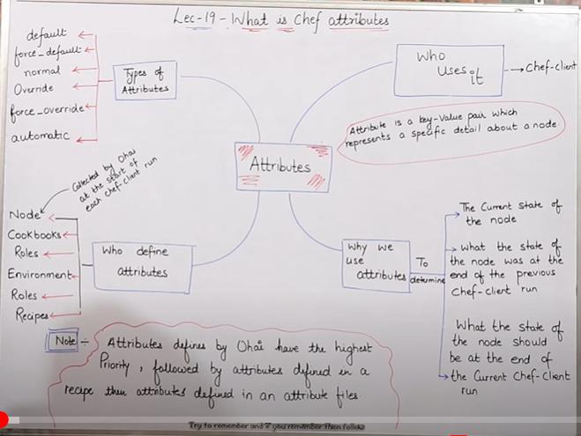

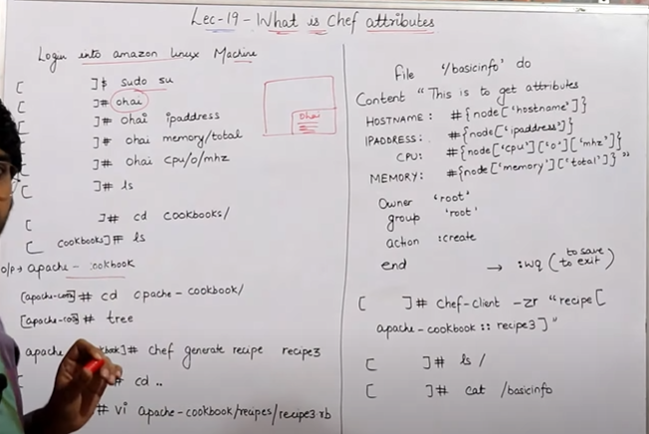

CODE USED IN THIS LAB****

file '/basicinfo' do

content "This is to get Attributes

HOSTNAME: #{node['hostname']}

IPADDRESS: #{node['ipaddress']}

CPU: #{node['cpu']['0']['mhz']}

MEMORY: #{node['memory']['total']}"

owner 'root'

group 'root'

action :create

end

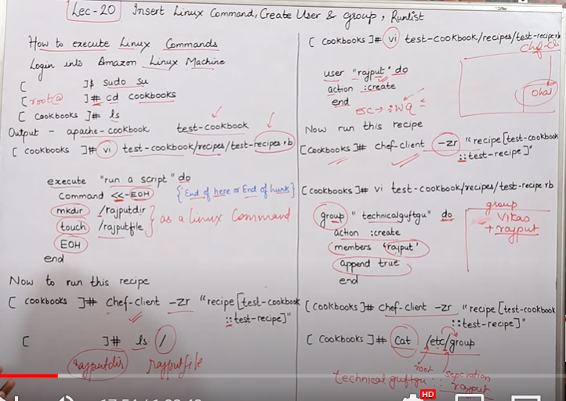

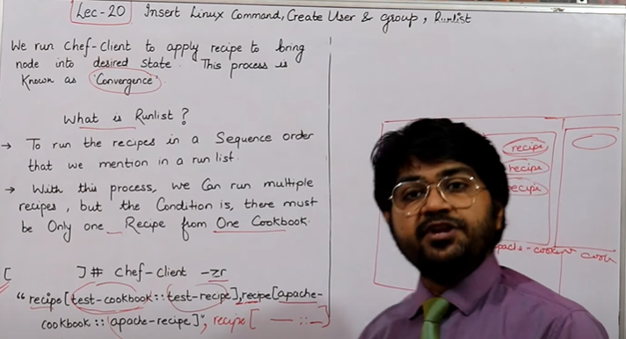

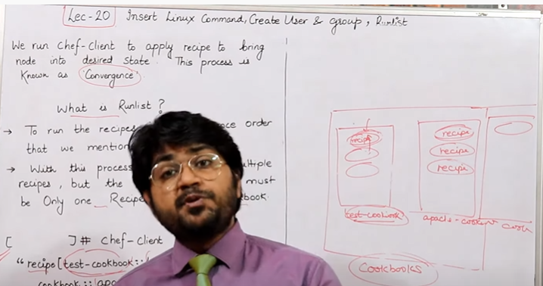

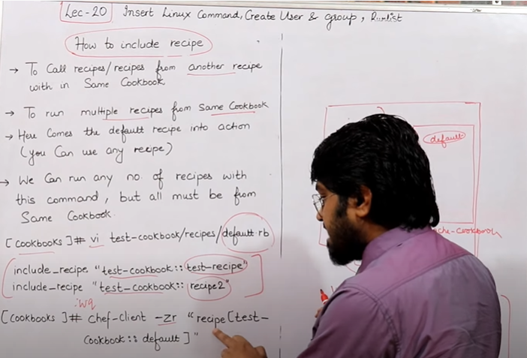

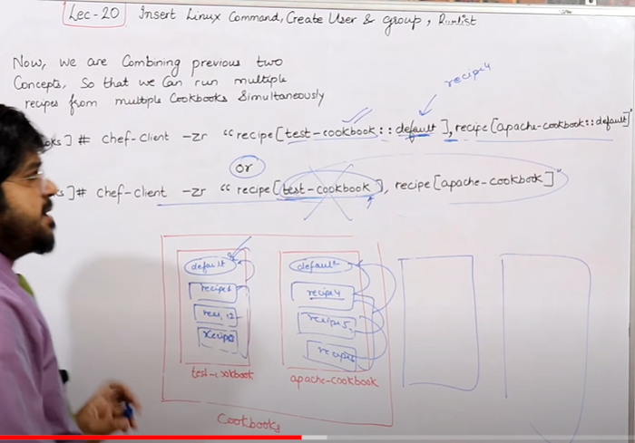

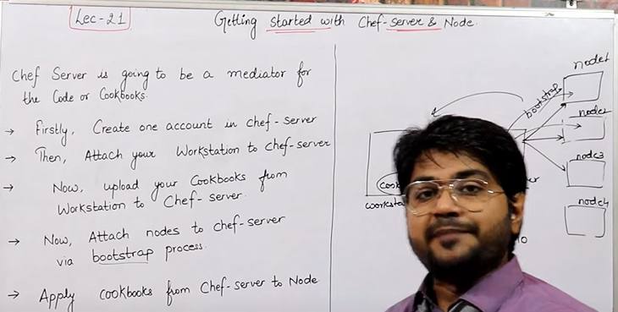

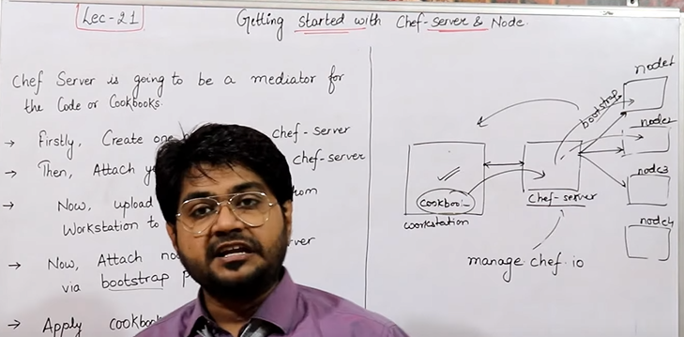

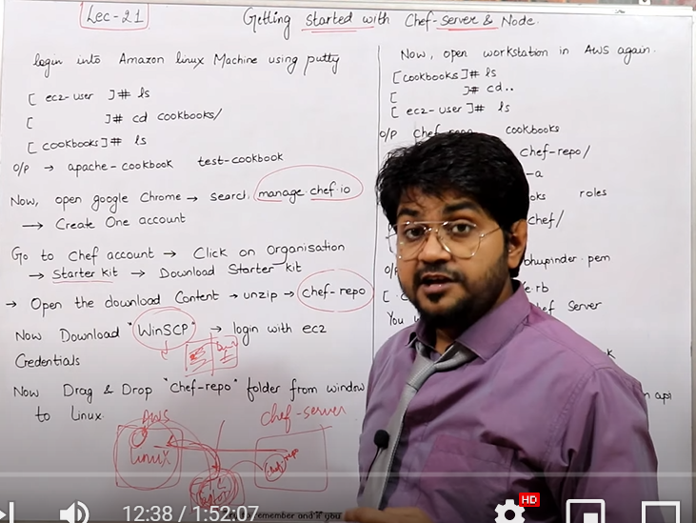

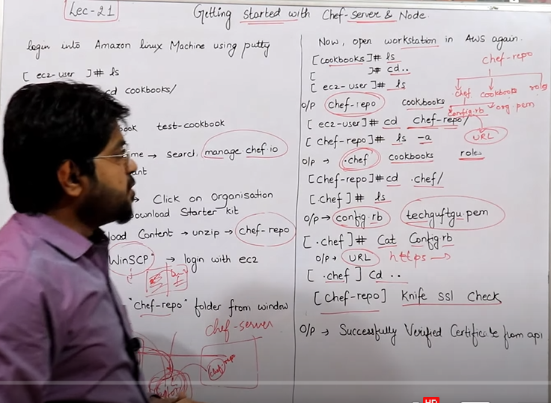

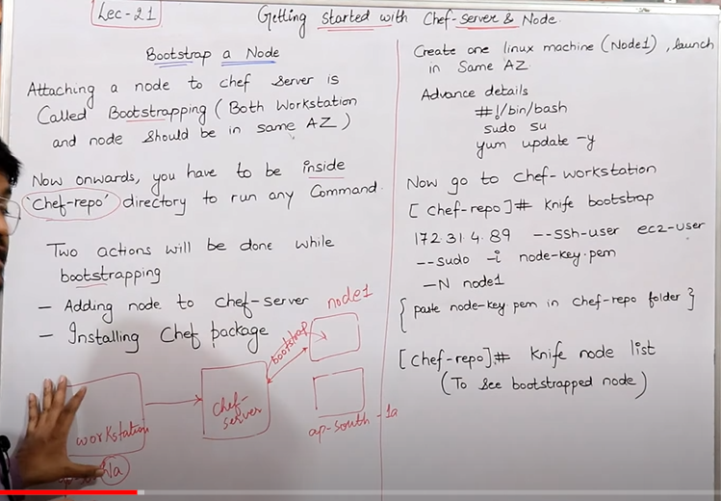

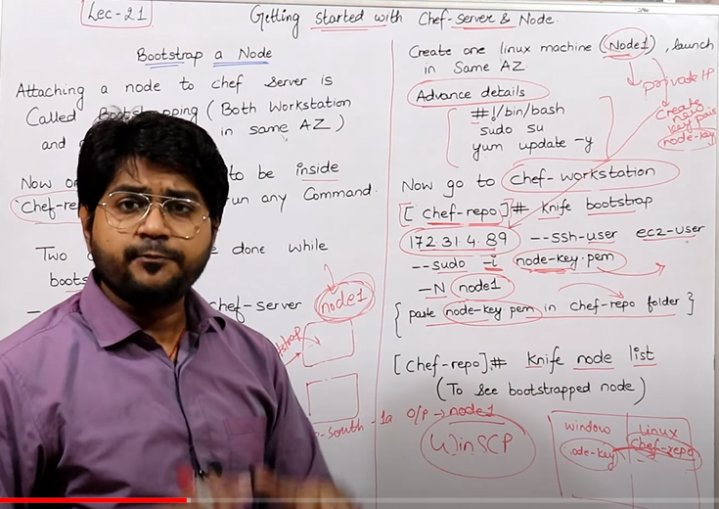

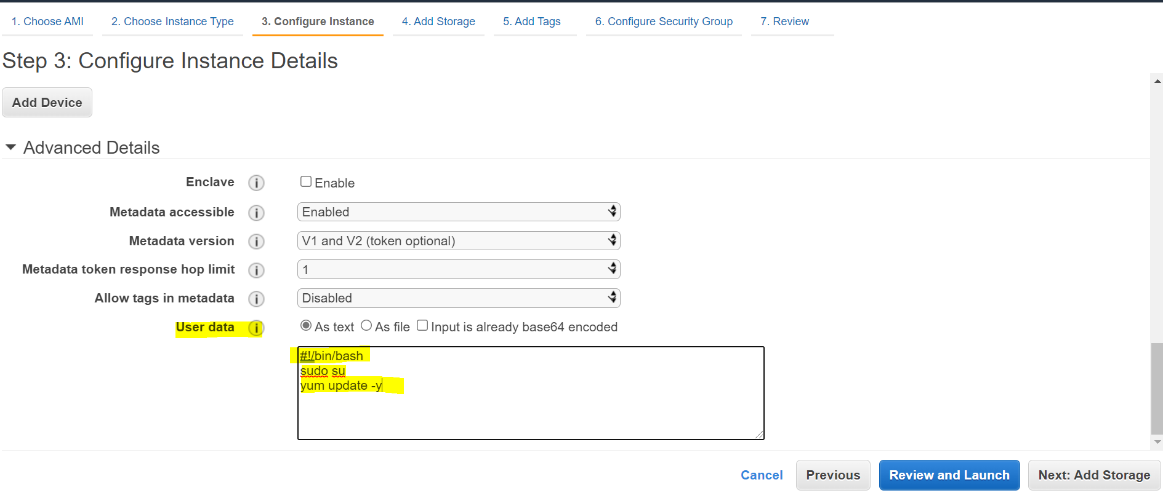

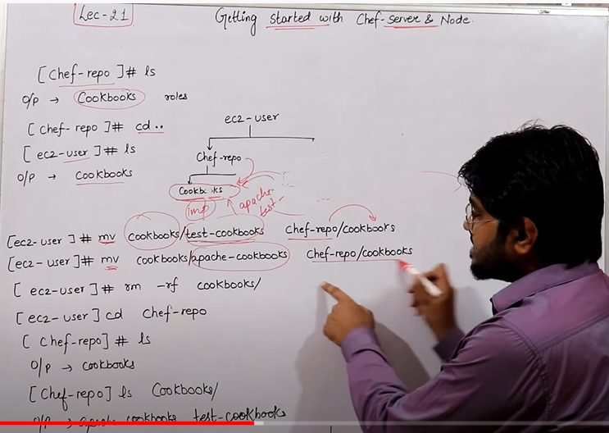

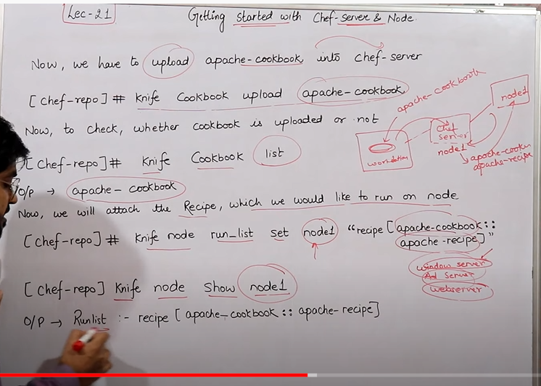

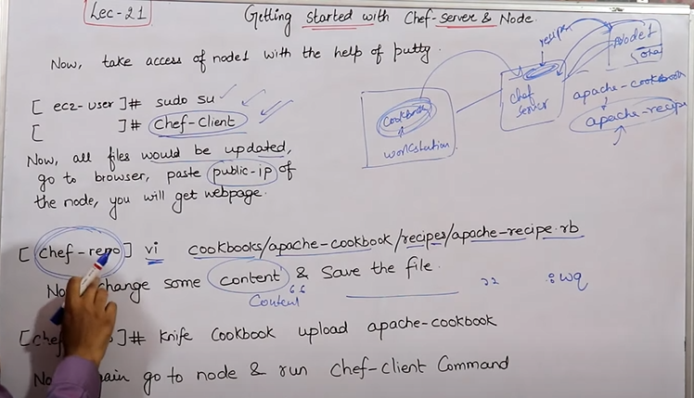

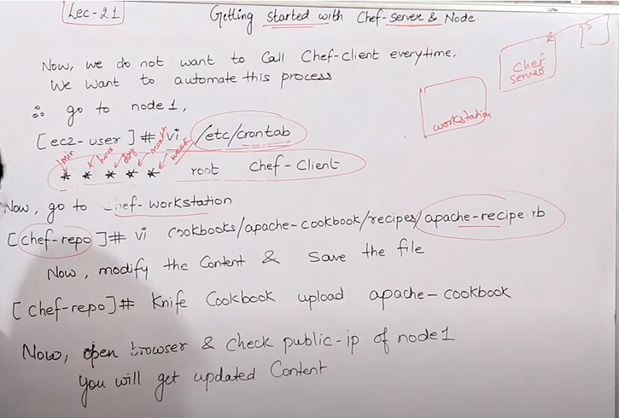

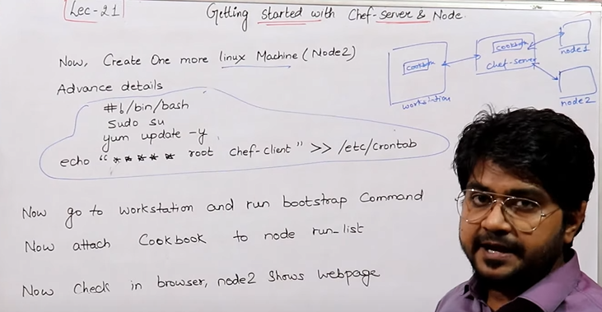

execute "run a script" do

command <<-EOH

mkdir /aryalfile

EOH

end

execute "run a script" do

command <<-EOH

mkdir /aryaldir

touch /aryalfile

EOH

end

-----------------------------------------------------------------------

# For details see man 4 crontabs

# Example of job definition:

# .---------------- minute (0 - 59)

# | .------------- hour (0 - 23)

# | | .---------- day of month (1 - 31)

# | | | .------- month (1 - 12) OR jan,feb,mar,apr ...

# | | | | .---- day of week (0 - 6) (Sunday=0 or 7) OR sun,mon,tue,wed,thu,fri,sat

# | | | | |

# * * * * * user-name command to be executed

------------------------------------------------------------------------------------------------------------------

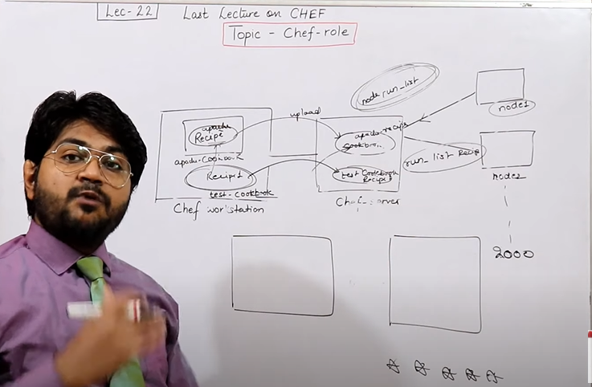

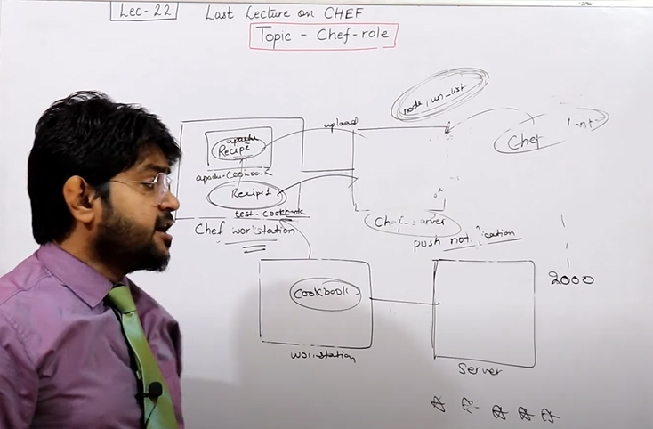

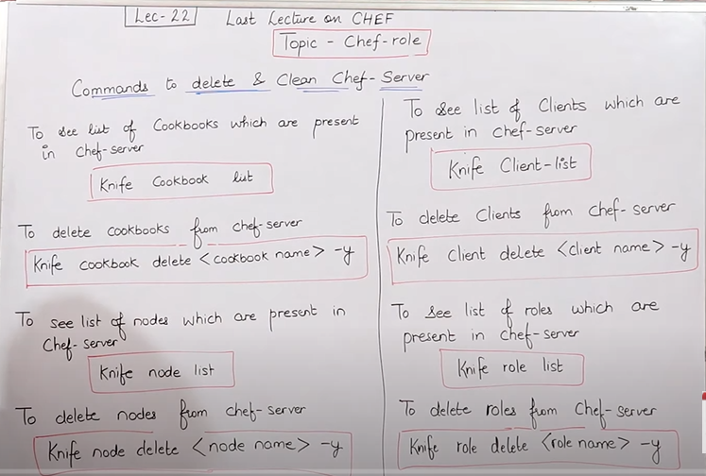

Knife cookbook list

Knife cookbook delete <cookbook name> -y

Knife node list

Knife node delete <node name> -y

Knife client-list

Knife client delete <client name> -y

Knife role list

Knife role delete <role name> -y

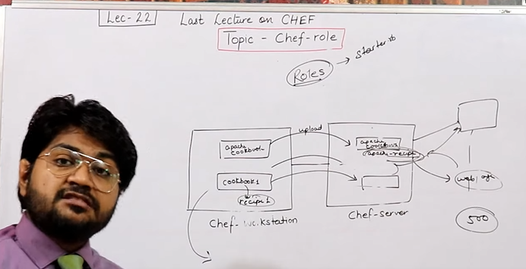

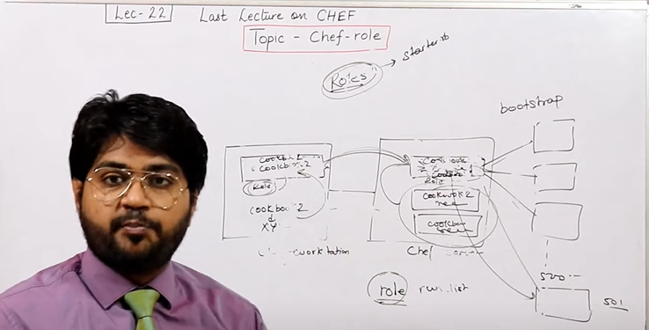

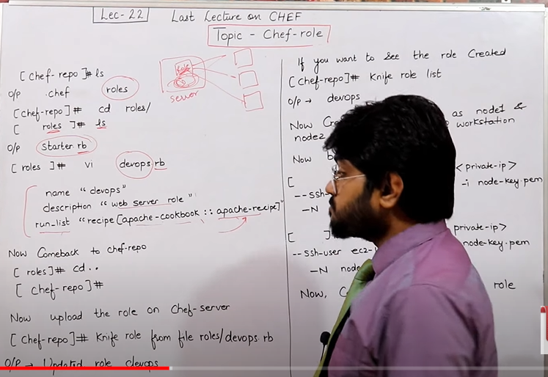

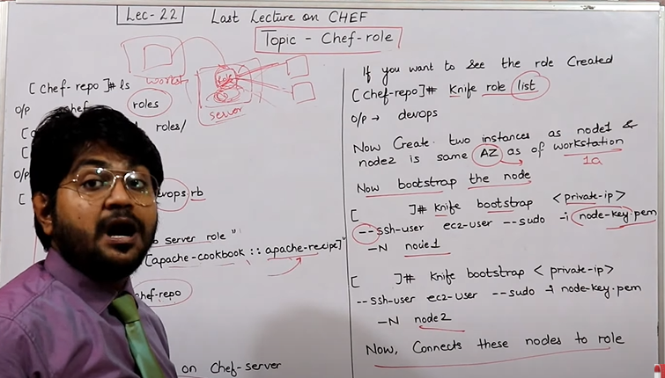

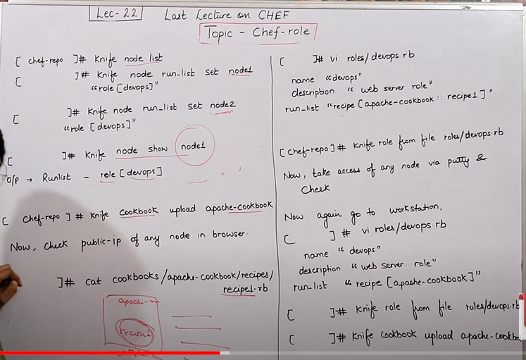

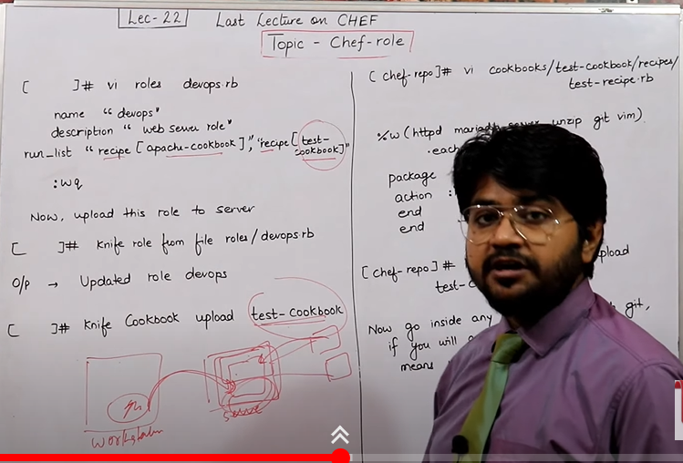

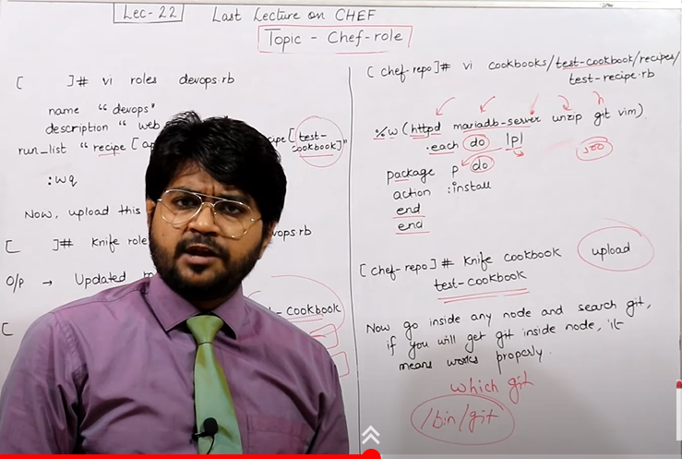

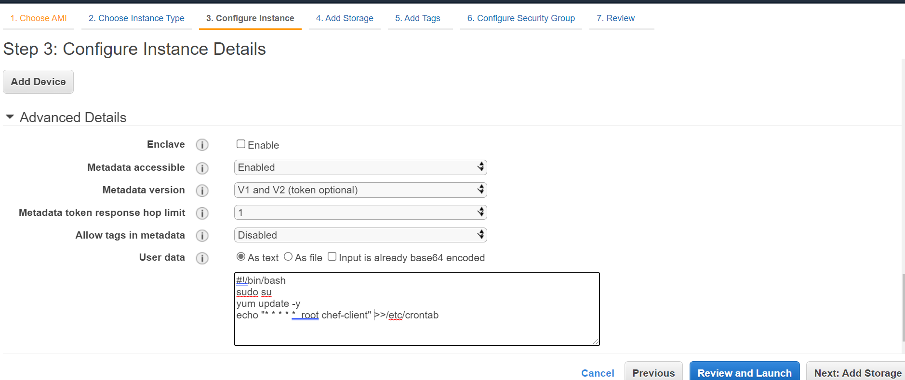

file '/robofile' do

content "This is to get Attributes"

HOSTNAME: #{node['hostname']}

IPADDRESS:#{node['ipaddress']}

CPU:#{node['cpu']['0']['mhz']

MEMORY: #{node['memory']['total']}

owner 'root'

group 'root'

action :create

end

-------------------------------------------

**OSI model (open system interconnection)**

**All People Seems To Need Data Processing (Top to bottom)**

**Please Do Not Throw Sauces Pizza Away (Bottom to Top)**

**Application Layer 🡪 Presentation Layer 🡪Session Layer 🡪Transport Layer 🡪 Network Layer 🡪Data Layer 🡪Physical Layer**

